- Chancellor Rachel Reeves' growth plan represents a step in the right direction but it's unlikely to have a material impact on UK growth prospects in this parliament. Gains from supply-side measures take time to emerge, while a shortage of construction workers will pose a practical challenge to increasing housebuilding and completing new infrastructure projects.
- The importance of boosting productivity was emphasised by the Office for National Statistics' latest set of population projections. Factoring in our more cautious assumptions for net inward migration, there's a good chance the working age population will be falling by the 2050s.
In a week light on economic data, the UK's long-run growth prospects took centre stage. New population projections from the Office for National Statistics reiterated that support from workforce expansion will progressively fade, emphasising the importance of addressing the UK's poor productivity performance.
The ONS's new population projections were based on the mid-year estimates for 2022 and factored in the much higher estimates of net inward migration for 2022-2024 published in November. As the ONS uses a ten-year average to project migration forwards, the higher recent history led to its long-run projection for net inward migration being revised up to 340,000 a year, from 315,000 (Chart 1). But the ONS also lowered its projections for natural change, reflecting a lower assumption for fertility. The net effect was minimal changes to the projections for total population over the next twenty years, but much lower forecasts from the mid-2040s onwards, as the impact of lower births continues to build.
The lower fertility assumptions look more defensible than the previous vintage but could still prove too optimistic. We think that using a ten-year average inflated by the visa schemes for migrants from Ukraine and Hong Kong yields net inward migration assumptions that are too high. Measures implemented by the previous government to cut legal immigration – including limiting the ability of foreign students to bring dependents to the UK, raising the minimum salary for a skilled worker visa, and increasing the minimum income required to qualify for a spousal visa – also suggest net immigration will likely be lower in future.
Chart 1: Lower projections for natural change more than offset the impact of higher immigration
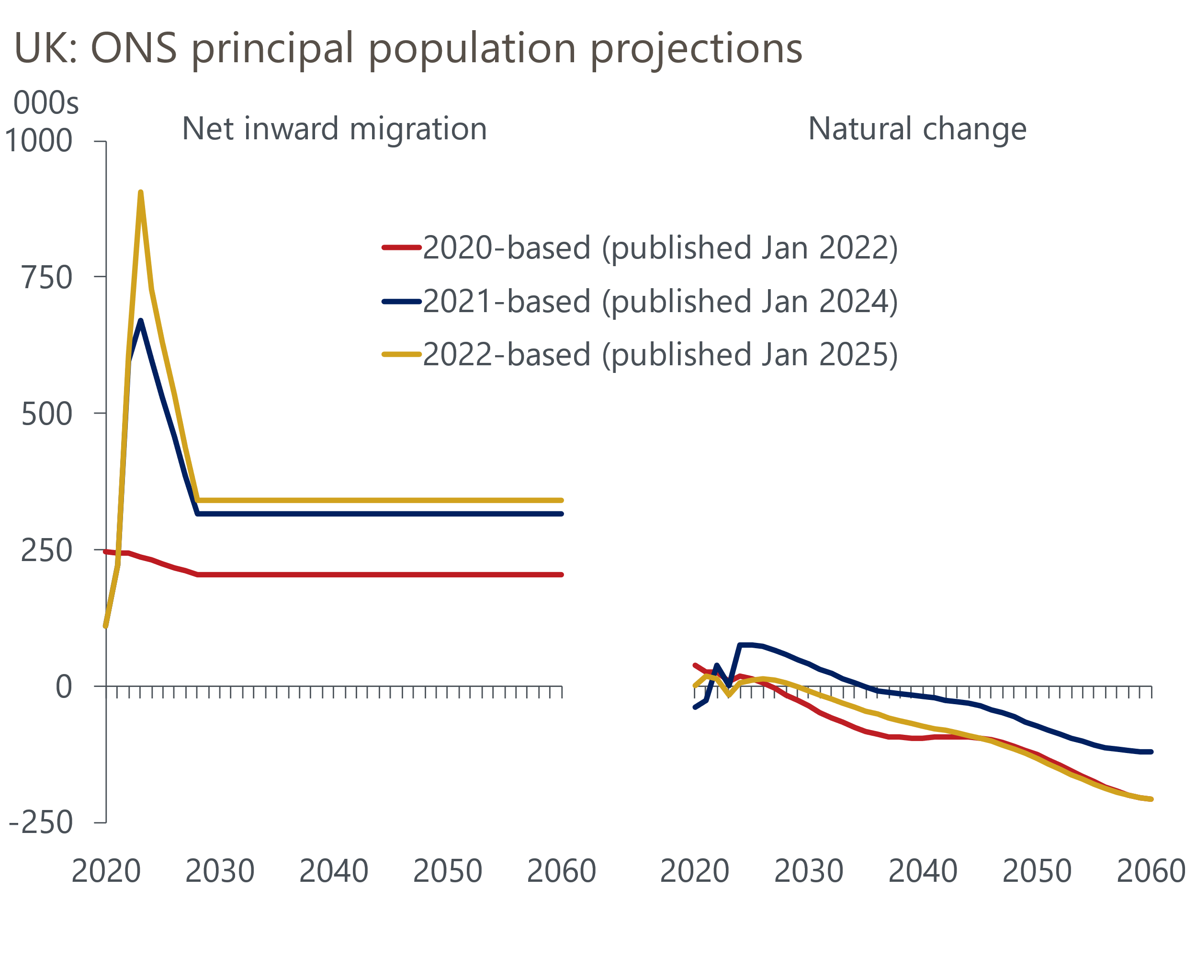
Source: ONS

We plan to continue our practice of basing our UK macroeconomic forecasts on the ONS's assumptions for natural change and then layering on our, lower, assumption for net inward migration. Previously we adopted the ONS' low migration variant, which assumed net inflows would be 20% lower than its principal projection. But the variants for the new projections have much larger differences and the new low migration variant of 120,000 a year looks implausibly low. So we will continue to assume that net inflows are 20% below the ONS' principal projection, giving a long-run assumption of 272,000 a year.
There's huge uncertainty surrounding these projections, not only over the longer-term but also for the next few years. This is partly because we have no data for the period since visa rules changed. But it also reflects uncertainty around how many of those people who have come to the UK in recent years will return home. Recognising this uncertainty, the ONS also published an extra variant that assumes a steeper drop in net inflows in the near-term before numbers ultimately move back into line with the principal projection by the end of the decade. We should gain a clearer understanding of whether this profile looks more realistic when the next migration data is published in May.
Our new assumptions imply population growth progressively slowing out to 2060. The picture for working age population looks worse, with barely any growth in the 2030s and an increase in the 2040s mostly due to the increase in the state pension age. By the 2050s, the population of working age is likely to be falling.
Chart 2: By the 2050s, we expect the UK's working age population to be shrinking
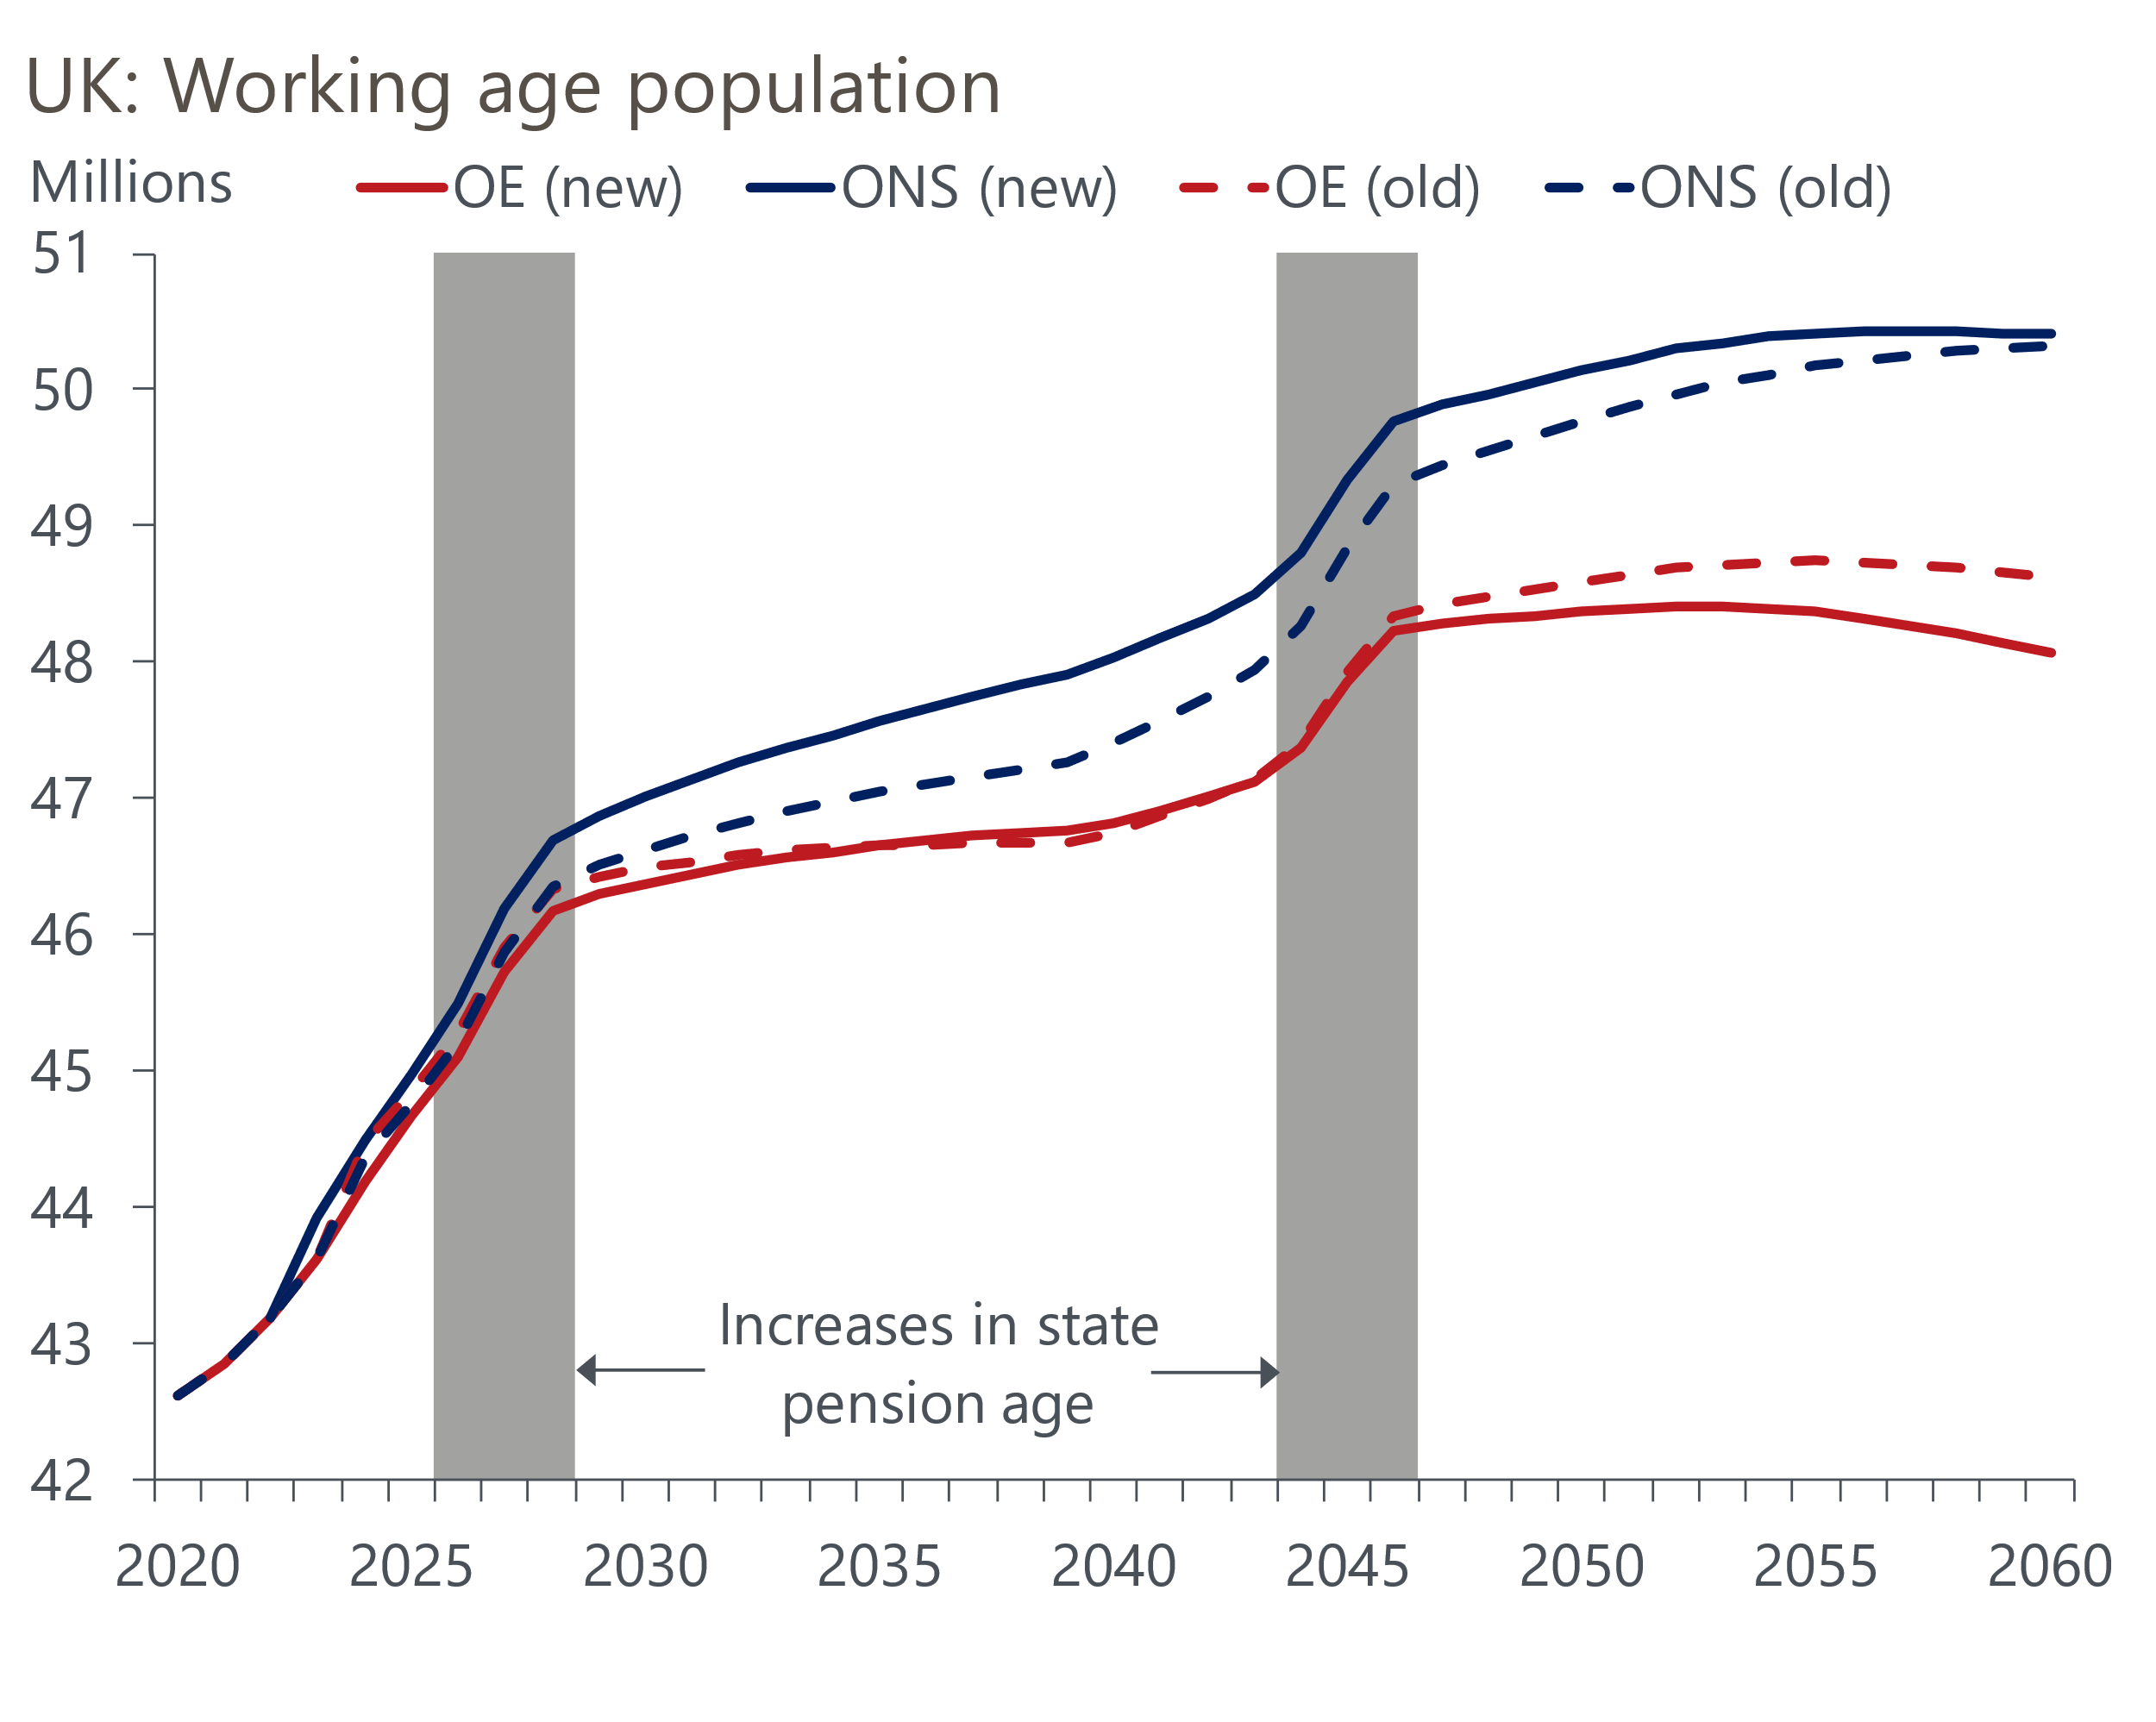
Source: Oxford Economics, ONS
The UK's growth performance has been poor since the Global Financial Crisis, even with strong support from expanding labour supply. So with demographics set to become less supportive, it's even more important that the UK finally solves its productivity problem.
Chancellor Rachel Reeves laid out her vision for boosting potential output in a speech this week. Her backing for a third runway at Heathrow Airport was one of several infrastructure projects announced, most of which are located in the south of England. She also emphasised there would be changes to the planning system to make it easier to build, and an overhaul of the welfare system, aimed at increasing participation and reducing the cost of state benefits.
Coming on top of much higher levels of investment announced in October's Budget, the outline of a growth plan is emerging. But as we argued in a note this week, raising potential output is hard and the benefits of supply-side policies take time to surface. The government also faces practical challenges. For example, severe labour shortages in the construction sector will hamper attempts to increase housebuilding and build new infrastructure.
So while the government's announcements are a step in the right direction, they’re not enough to shift the dial on our growth forecasts over the next five-to-ten years. And any boost to potential output growth from stronger productivity further out will be mitigated by the impact of worsening demographics.

The week ahead
The highlight of next week's calendar is the Bank of England's Monetary Policy Committee meeting. We expect an 8-1 vote in favour of cutting Bank Rate by 25bps to 4.5%, with Catherine Mann as the sole dissenter. This would continue the 'cut-hold' pattern followed since the MPC kicked off the rate cutting cycle last summer. It would also be in keeping with the more dovish messaging in the minutes of December's meeting, when the MPC said that it was becoming more concerned about the implications of recent weakness in activity and employment data.
Data wise, we will see the final results from S&P Global's January surveys. The flash survey reported modest rises in the manufacturing, services, and composite PMIs, though the balances remained well below the levels seen in H1 2024 and manufacturing activity was still contracting. Given the flash survey was conducted from January 9-22 against a backdrop of significant financial market volatility, we see some upside risk to the final results.
Table 1: Week ahead calendar
Date | Events | Period | Measure | Unit | Previous | Forecast
Feb 3 | S&P Global manufacturing | Jan | PMI | % bal | 48.2 | 48.2
Feb 5 | S&P Global services | Jan | PMI | % bal | 51.2 | 51.2
Feb 5 | S&P Global composite | Jan | PMI | % bal | 50.9 | 50.9
Feb 6 | S&P Global construction | Jan | PMI | % bal | 53.3 | 53.5
Feb 6 | BoE Bank Rate decision | Feb | Bank Rate | % | 4.75 | 4.50
Source: Oxford Economics

Key forecasts
Table 2: UK forecast overview
(Annual percentage changes unless specified)
 | 2022 | 2023 | 2024 | 2025 | 2026 | 2027
GDP | 4.8 | 0.4 | 0.8 | 1.1 | 1.7 | 1.8
Private consumption | 7.3 | 0.4 | 1.0 | 1.3 | 1.5 | 1.6
Fixed investment | 5.1 | 0.3 | 1.1 | 0.3 | 3.3 | 2.6
Government consumption | 0.6 | 1.0 | 2.1 | 2.6 | 1.6 | 1.6
Exports of goods and services | 12.6 | -3.2 | -2.5 | -0.6 | 1.6 | 1.6
Imports of goods and services | 13.0 | -4.5 | 1.6 | 0.4 | 1.8 | 1.5
Industrial Production | -6.4 | -0.9 | -1.6 | -0.3 | 1.2 | 1.2
Consumer prices | 9.1 | 7.3 | 2.5 | 3.0 | 2.5 | 2.1
Unemployment rate (%) | 3.8 | 4.1 | 4.3 | 4.5 | 4.4 | 4.2
Current a/c balance (% of GDP) | -2.2 | -2.2 | -2.8 | -3.0 | -2.9 | -2.7
Government balance (% of GDP) | 4.1 | 5.2 | 4.9 | 3.2 | 2.8 | 2.2
Central bank policy rate (%, EOP) | 3.50 | 5.25 | 4.75 | 3.75 | 3.00 | 2.50
10yr govt. bond yield (%, EOP) | 3.67 | 3.54 | 4.57 | 4.31 | 3.89 | 3.44
Exchange rate (US$ per £, EOP) | 1.20 | 1.27 | 1.25 | 1.26 | 1.27 | 1.28
Exchange rate (euro per £, EOP) | 1.13 | 1.15 | 1.21 | 1.19 | 1.19 | 1.19
Source: Oxford Economics
Table 3: Quarterly forecasts for the UK
 | 2024 |  |  |  | 2025
 | Q1 | Q2 | Q3 | Q4 | Q1 | Q2 | Q3 | Q4
GDP (% year) | 0.3 | 0.7 | 0.9 | 1.1 | 0.8 | 0.8 | 1.1 | 1.6
CPI inflation (% year) | 3.5 | 2.1 | 2.1 | 2.5 | 2.7 | 2.8 | 3.3 | 3.1
Bank Rate (%, EOP) | 5.25 | 5.25 | 5.00 | 4.75 | 4.50 | 4.25 | 4.00 | 3.75
10yr gilt yield (%, EOP) | 3.95 | 4.17 | 4.00 | 4.57 | 4.50 | 4.46 | 4.39 | 4.31
US$ per £ (EOP) | 1.26 | 1.26 | 1.34 | 1.25 | 1.23 | 1.24 | 1.25 | 1.26
Euro per £ (EOP) | 1.17 | 1.18 | 1.20 | 1.21 | 1.19 | 1.19 | 1.19 | 1.19
Source: Oxford Economics

Latest Country Economic Forecast:
January 22, 2025

Recent publications

Data Insights
Mortgage approvals picked up a little at the end of 2024
The PMIs started 2025 on a slightly brighter note
Government has little fiscal room for manoeuvre
November's labour market data underscores the MPC's dilemma
Retail sales fall back in December on weakness in food stores

Research Briefings
MPC preview – Maintaining the dovish message
A plan for growth - next steps
Labour market data woes show the importance of nowcasts
Three key uncertainties cloud the labour market outlook
Weakness in sterling and gilts - causes and consequences

Contacts

Oxford Economics' UK team
- Andrew Goodwin - Chief UK Economist - agoodwin@oxfordeconomics.com
- Edward Allenby - UK Economist - eallenby@oxfordeconomics.com

